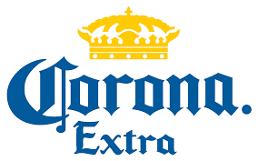

The Greater Coeur d’Alene USBC
Presents
$750.00 Added to the Prize Fund
The Seventh Annual Greater CDA Masters
June 11th & 12th, 2022
River City Lanes 965 W. Seltice Way, Post Falls, ID 83854
- This will be a scratch singles tournament.
- Participants will bowl 6 qualifying games.
- The top 16 bowlers will advance to the finals on Sunday at 9am.
- The finals will be a double elimination bracket style final with seedings determined from the qualifying round.
- Total pin-fall will determine final seeds and match winners
- This will be a certified USBC tournament.
- There will be 2 qualifying squads. Bowlers may enter up to 2 times to attempt to qualify.
- The total cost of the tournament shall be $155. Lineage and fees for qualifying round will be $38.
- The defending Masters champion will receive a spot in the finals but must still compete in the qualifying round for seeding purposes.

USBC ID# | Name | Phone Number | 8am | 11:30am
Please select a squad time for qualifying.
If you have any questions or would like to reserve a spot in the tournament, please contact John Campisi 208-215-5021.

